**ST. ANDREWS INSTITUTE**

**OF TECHNOLOGY & MANAGEMENT**

**Gurugram Delhi (NCR)**

**Approved by AICTE, Govt. of India, New Delhi**

**Affiliated to Maharshi Dayanand University**

**‘A+’ Grade State University, accredited by NAAC**

**Session: 2024 – 2025**

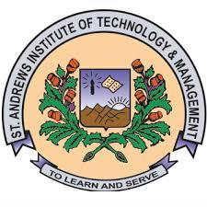

**Practical Software Lab: Web Development**

**Course Code: BCA-** **24CSC401SE01**

**Semester: 1st**

**Bachelor of Computer Applications**

**Submitted By**

**Name:**

**Roll No.:**

**DEPARTMENT**

**OF**

**COMPUTER APPLICATIONS**